State of the Art

Cloud computing is changing the style in which services are delivered over the Internet. A cloud service is able to supply scalability according to the demand, to provide functionality without dealing the underlying technologies that conform the cloud, and to leverage the distributed physical infrastructure for using the cloud as a virtual pool of resources (pay as you need).

The integration of the cloud with mobile technologies has envisioned the Mobile Cloud Computing domain (MCC). This chapter introduces these developments from the literature and addresses the
motivation for the research in the MCC domain.

Cloud Domain

Cloud computing is a style of computing in which, typically, resources scalable on demand are provided “as a service (aaS)” over the Internet to users who need not have knowledge of, expertise in, or control over the cloud infrastructure that supports them. Cloud computing mainly forwards the idea of utility computing along with virtualization. In the utility computing model, consumers pay based on their usage of computing resources, just like the traditional utility services e.g. water, electricity, gas etc. Just like any utility services model cloud computing benefits from economies of scale. On the other hand, virtualization technologies partition hardware and thus provide flexible and scalable computing platforms. Servers in the cloud can be physical machines or virtual machines. A cloud computing platform dynamically provisions, configures, reconfigures, and de-provisions servers as requested.

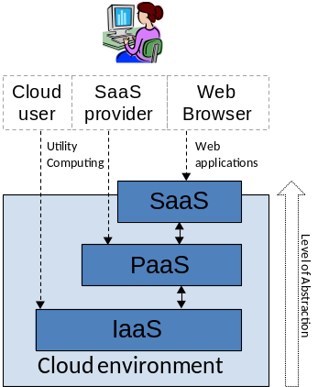
- Level of abstraction and layers of cloud services

Mobile technologies

Since the introduction of iOs (2007) and Android (2008) as mobile platforms for the smartphones; a huge popularity has been growing around this two operating systems as basis for the development of mobile applications. Apple released iOs as platform for their own device (iPhone). Similary, Android was released as open source in the consortium of the Open Handset Alliance Currently, Android is supported for vendors such Samsung, Sony Ericcson, HTC, Toshiba, LG among others.

Smartphones

its a mobile device that offers advances features regarding computing capabilities, connectivity access, ergonomic design and a better interaction experience with the user. Smartphones allows to run applications (multithreading) that are native to the underlying technology.

Mobile applications are developed for a diversity of mobile platform including Symbian (Nokia), Windows Mobile (Microsoft), Blackberry (Sony Ericsson) etc. Recently, Symbian have been replaced from the Market for Windows Mobile since the popularity of this decrease in the mobile market.

Sensors
Smartphones are rich of a variety of sensors that enables sensing the user environment for providing adaptability in real-time.
Accelerometer
its an embedded sensor within the mobile phone that is use for the sensing the acceleration of the device in different axes (generally 3). The accelerometer can be used for providing multiple services, for example, vendors are using the accelerometer as a security mechanism for securing the hard disk when the device experience a free fall.

Magnetic Field
This sensor is able to sense changes in the magnetic field of the objects, since the magnetic field shows variation that are related with movements, this kind of sensor may be used for collecting precise information such distance, direction etc.

Android Platform

Its a mobile platform released by the Open Hanset Alliance that consist in a software stack composed by an operating system, middleware and key applications []. The development of software is tied to the use of the Delvik Virtual Machine (Android Runtime) that enables the use of Java as programming language. Most of the libraries which are compatible with a JDK, can be deployed within Android. However, Some of them may present issues concerning compatibility with the compiler and thus, are unable to be executed. For example typica API presents such integration problems.

Android
architecture consists of multiple layers that relies on a Linux kernel as shown in figure. The application layer includes a set default applications within the operating system such calendar, contacts, etc. Those applications can be synchronized with the cloud using Google sync. The application framework consist in predetermined services for managing device resources as hardware (sensors, screen, etc ), software (alarms, background services ) and the integration with external sources (location information systems, AC2DM notification service, etc).
Within the set of libraries, Android incorporate those that provide real-time performance. For example a light version of SQLite database is include.

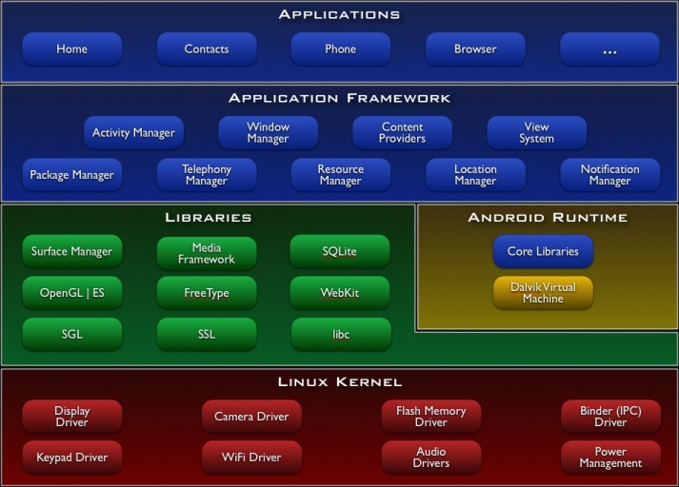

Figure : Android Architecture

The distribution of applications for Android is through the Android market. Although, applications can be distributed freely over the Internet once they are packed in APK (Android Package Files) files. However, if the application it was not purchased in the Android Market, still it may be installed, but under the risk of acquire Android Malware.

iOS Platform

its a mobile platform owned by Apple, Inc. that's its deployed for its mobile device (iPhone). Since its a proprietary technology most of its core functionality altogether with the hardware is not accessible for the developer. iOS consists of a number of multiple software layers, each layer allows the use of programming frameworks for the development of applications that run on top of the underlying device architecture.

iOS architecture is depicted in figure. The conception of each layer allows multiple levels of abstractions for dealing with the hardware. The complexity of each layer is related with the lines of code needed for achieve the developer objective in the mobile application. In general, the higher level of layer, the less effort required for building the application.

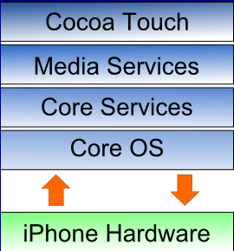

Figure: iOS architecture

Cocoa Toach Layer is the higher layer of the iOs platform that is based in c-objective language, it provides services such Push Notification Service, Game Kit Frameworks, among others. Media Layer provides capabilities for reproducing video, audio altogether with graphics capabilities for animations. The core services layer contains another abstraction the services described in Cocoa Toach and Media Services. The Core OS Layer lies in the bottom position of the iOS stack and, as such, sits directly on top of the device hardware. The layer provides a variety of services including low level networking, access to external accessories and the usual fundamental operating system services such as memory management, file system handling and threads.

The distribution of application is exclusively through the iPhone App Store. A developer that desires publish an applications must submitted first for inspection in the iOS Dev Center. Once, the review is done and the application fits the mandatory requirements requested by Apple, just then the application is published.

Mobile Cloud Services

Clouds are looking forward to the mobile domain, having their expectations focused in the idea of data synchronization services. Mobile sync refers to the synchronization of data in the handset with a server and a portal in the cloud. This kind of approach takes advantage of the cloud allowing the centralization of data resources (contacts, e-mail, pictures, etc.) in the storage service, from several sources (social networks, email providers, etc.), for being accessible via SyncML (Synchronization Markup Language) protocol, in such a way that empowers the managing of real-time information from the handset. (Mobile sync architecture is show in figure ). SyncML is a protocol referenced by the OHA for being used as standard to another synchronization data solutions used for specific vendors.

Cloud vendors offer a solution for synchronization based on their cloud implementation. For Instance, Google sync (Google), MobileMe (Apple), MyPhone (Microsoft) Ovi Sync (Nokia) etc. In some cases, such solutions are inherent for devices such Android and iPhone. Moreover, providers as Apple unable another kind of devices connecting with its synchronization services.
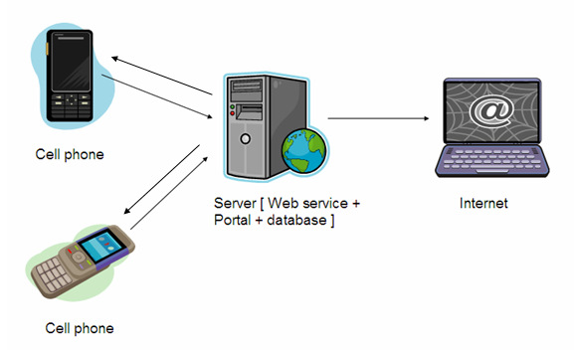

Figure: Mobile Cloud synchronization architecture

Funambol

Its an open source framework for the synchronization of data between the handset and a private cloud. Funambol enables the synchronization of information such contacts, calendar, images and latest versions include a feature for pushing email to the handset. Funambol is considered the most spread it solution due several platforms can consume their service without being constrained for an specific cloud implementation .

